
For immediate release: Wednesday 29 April 2026
Iain Tuckett to step down as Chief Executive
of Coin Street Community Builders

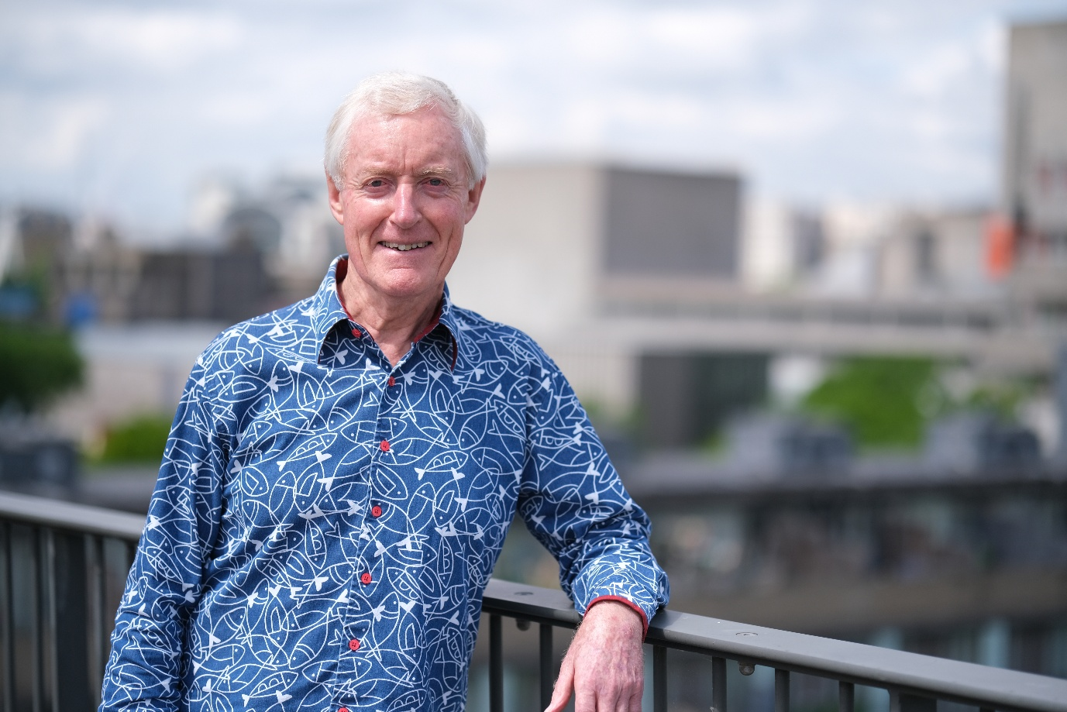

Coin Street Community Builders today announces that Iain Tuckett will step down as chief executive and founder member of Coin Street Community Builders after over 40 years leading the social enterprise. The Board has now begun a search for Coin Street’s next chief executive. Iain will oversee an orderly transition before retiring in December 2026.

Between 1975 and 1984 Iain led the campaign for the then derelict 13-acre ‘Coin Street site’ on London’s South Bank to be used for housing, workshops, a riverside park, and leisure uses rather than the proposed development of over 1 million square feet of offices. Working with other central London communities, Iain founded and worked for CHiCL (the Campaign for Homes in Central London) which proposed a ‘Community Areas Policy’ to support the reintroduction of housing in areas such as Covent Garden, Fitzrovia, Battersea, North Southwark, Paddington and Spitalfields – all of which had suffered substantial drops in residential population during the 1960s and 1970s. Before it was abolished in 1986, the GLC under the leadership of Ken Livingstone adopted the Community Areas Policy as a ‘Life Belt’ to support homes and community facilities around London’s city centre in the same way that the ‘Green Belt’ protected countryside around Greater London.

One outcome of the GLC policy was the sale in 1984 of the 13-acre Coin Street site (between Waterloo and Blackfriars Bridges) for £1million to Coin Street Community Builders, a social enterprise established by local residents to pursue ‘public service otherwise than for gain’.

As well as acting as chief executive, Iain has overseen all property developments on the Coin Street site including Oxo Tower Wharf, 220 social rent homes for 4 housing co-operatives, Coin Street neighbourhood centre, Bernie Spain Gardens, and the completion of the South Bank riverside walkway. On its ‘Doon Street site’ (adjacent to the National Theatre), Iain was responsible for the innovative arrangement whereby Coin Street Community Builders leased land to Rambert to build its new headquarters and dance studios at a rent of one pair of ballet shoes per annum – and an extensive community dance engagement programme. The next phase of the site includes a large public swimming and indoor leisure centre to be owned and managed by Coin Street Centre Trust.

Under Iain’s leadership, Coin Street Community Builders has worked closely with its neighbours to establish South Bank Employers’ Group in 1991, South Bank Partnership in 1995, South Bank Business Improvement District in 2014, and South Bank & Waterloo Neighbours (SoWN) in 2015. Iain was a founder member of the Development Trusts Association (now Locality) and played an active part in the formation of Social Enterprise UK.

On behalf of the Cross River Partnership, Iain planned and project managed the introduction of the RV1 bus route which opened in 2002 and linked Covent Garden, the South Bank, Bankside, and the Tower of London. After pioneering London’s first hydrogen fuel cell buses, the service was closed in 2019.

Iain was a founder member of the Thames Festival Trust which launched with an iconic wire walk across the Thames in 1997 and still delivers the annual ‘Totally Thames’ programme. Iain was a trustee of the Young Vic Theatre from 2000-2008 with a particular brief to oversee the rebuilding of the theatre.

Iain is a founder member and trustee of Jubilee Gardens Trust which completed the relandscaping of the park between the London Eye and Royal Festival Hall in 2012. The Trust now manages the Gardens on a 125-year lease.

Iain Tuckett said: “It has been a joy to work with so many committed staff and board members over the years and to see London’s South Bank transformed. I also want to pay tribute to the many design teams with whom I have worked, particularly architects Lifschutz Davidson Sandilands, Haworth Tompkins, Marks Barfield and Carmody Groarke – and the engineers and cost consultants who have ensured our dreams can be realised. It is a privilege to be chief executive of an organisation with such reach and opportunities and I’m really excited to see how a new CEO will shape Coin Street’s future.”

[ends]

NOTES TO EDITOR

About Coin Street Community Builders
We are a social enterprise working in Waterloo and North Southwark, London. From a derelict site in 1984, we have created a vibrant, diverse and welcoming place for people to live, work and play. https://coinstreet.org/

Executive Search Partner
We have partnered with GatenbySanderson to lead the search process for our next Chief Executive. Gatenby Sanderson identifies, recruits and develops exceptional talent to help organisations build stronger boards and leadership teams. With Client and candidate central to their approach, they have a world-class Net Promoter Score rating. Full details of the process will be available shortly via GatenbySanderson.

For more information
Keith Winestein
Communications and Media Manager
k.winestein@coinstreet.org 020 0721 1681 (direct/mobile)

