Coin Street Summary Safeguarding Policy

- Summary

This document is a summary document intended to convey key safeguarding information to
- volunteers
- short term agency staff
- any staff not working consistently at Coin Street with children, young people or vulnerable adults

All staff working consistently at Coin Street with children, young people or vulnerable adults are expected to read and be familiar with the full Coin Street Safeguarding Policy and Procedures available separately.

- Safeguarding Policy Statement

This safeguarding policy and its procedures underpin all activity which involves working with children, families, young people and vulnerable adults.

The purpose of this policy is to protect children, young people and vulnerable adults and to provide parents, staff and volunteers with the overarching principles that guide our approach to safeguarding. This policy applies to anyone working on behalf of the Coin Street including senior managers and trustees, paid staff, volunteers, sessional workers, agency staff and students.

We believe that

- The welfare of the child, young person or vulnerable adult is paramount, and it is always unacceptable for a person to experience abuse or neglect of any kind
- All children, young people and adults, regardless of age, disability, gender reassignment, race, religion or belief, sex, or sexual orientation have a right to equal protection from all types of harm or abuse
- We have a responsibility to promote the welfare of all children, young people and vulnerable adults to keep them safe, and to practise in a way which protects them
- Working in partnership with children & young people, their parents, carers and other agencies is key to promoting their welfare
- Adults who work with children, young people and vulnerable adults are responsible for their own actions and behaviour and should avoid any conduct which would lead any reasonable person to question their motivation and intentions

We are committed to practice that protects children, young people and vulnerable adults from harm and we recognise our duty to ensure appropriate action is taken where a child, young person or vulnerable adult is experiencing harm or is at risk of harm.

Throughout this document references are made to ‘children’ and ‘young people’. These terms are interchangeable and refer to children who have not yet reached their 18th birthday.

A vulnerable adult is a person over the age of 18 who is or may be for any reason unable to take care of himself or herself, or unable to protect himself or herself against significant harm or exploitation. Adults aged 18 and over have the potential to be vulnerable (either temporarily or permanently) for a variety of reasons and in different situations.

An adult may be vulnerable if he/she has a learning or physical disability; a physical or mental illness, chronic or otherwise, including an addiction to alcohol or drugs; a reduction in physical or mental capacity; is in the receipt of any form of healthcare; is detained in custody; is receiving community services because of age, health or disability; is living in sheltered or residential care home; or is unable, for any other reason, to protect himself/herself against significant harm or exploitation.

- Types and Effects of Abuse

Abuse is a deliberate act of ill-treatment that can harm or is likely to harm a person’s safety, wellbeing and development. There are four formal categories of abuse. These are:

Physical abuse

Physical abuse may involve hitting, shaking, throwing, poisoning, burning or scalding, drowning, suffocating, or otherwise causing physical harm to a child or adult. Physical harm may also be caused when a parent fabricates the symptoms of, or deliberately induces, illness in a child. Female Genital Mutilation (FGM) also falls under this category as an offence.

Physical abuse indicators
Physical indicators | Behavioural indicators
Unexplained injuries – bruises / abrasions / lacerations  The account of the accident may be vague or may vary from one telling to another  Unexplained burns  Regular occurrence of unexplained injuries  Most accidental injuries occur on parts of  the body where the skin passes over a bony protrusion. | Withdrawn or aggressive behavioural extremes  Uncomfortable with physical contact  Seems afraid to go home  Complains of soreness or moves  uncomfortably  Wears clothing inappropriate for the weather,  in order to cover body.  The interaction between the child and its  carer
.
Neglect

The persistent failure to meet a child or vulnerable adult’s basic physical and/or psychological need likely to result in the serious impairment of their health or development. Neglect may occur during pregnancy because of maternal substance abuse. Once a child is born it may involve a parent failing to:

- Provide adequate food, clothing or shelter (including exclusion from home or abandonment)
- Protect a child from physical and emotional harm or danger
- Ensure adequate supervision (including the use of inadequate care-givers)
- Ensure access to appropriate medical care or treatment

It may also include neglect of, or unresponsiveness to, a child’s basic emotional needs.

Neglect indicators
Physical indicators | Behavioural indicators
Unattended medical need  Underweight or obesity  Recurrent infection  Unkempt dirty appearance  Body odour issues  Inadequate / unwashed clothes  Consistent lack of supervision  Consistent hunger  Inappropriately dressed | Poor social relationships  Indiscriminate friendliness  Poor concentration  Low self-esteem  Regularly displays fatigue or lethargic  Frequently falls asleep in class  Frequent unexplained absences

Emotional Abuse

The persistent emotional ill treatment of a child or vulnerable adult. It may involve conveying to a child or young person that they are worthless or unloved, inadequate or valued only insofar as they meet the needs of another person. It may feature age or developmentally inappropriate expectations being imposed on children. These may include interactions that are beyond the child’s development capability, as well as overprotection and limitation of exploration and learning, or preventing the child participating in normal social interaction. It may involve seeing or hearing the ill treatment of another (for example in cases of domestic violence). It may involve serious bullying, causing children or vulnerable adults to frequently to feel frightened or in danger, or the exploitation or corruption of children. Some level of emotional abuse is involved in all types of maltreatment of a child or vulnerable adult, though it may occur alone.

Emotional abuse indicators
Physical indicators | Behavioural indicators
Poor attachment relationship  Unresponsive / neglectful behaviour towards the child’s emotional needs  Persistent negative comments about the child.  Inappropriate or inconsistent expectations  Self-harm | Low self-esteem  Unhappiness, anxiety  Withdrawn, insecure  Attention seeking  Passive or aggressive behavioural extremes
Sexual Abuse
Forcing or enticing a child, young person or vulnerable adult to take part in sexual activities, not necessarily involving a high level of violence, whether or not the child or adult is aware of what is happening. The activities may involve physical contact, including assault by penetration (for example rape or oral sex) or non-penetrative acts such as masturbation, kissing, rubbing and touching outside of clothing. They may also include non-contact activities, such as involving children in looking at, or in the production of, sexual images, watching sexual activities, encouraging children to behave in sexually inappropriate ways, or grooming a child in preparation for abuse (including via the internet). Sexual abuse can be perpetrated by adult men and women, as well as children against other children.

Sexual abuse indicators
Physical indicators | Behavioural indicators
Sign of blood / discharge on the child’s underclothing.  Awkwardness in walking / sitting  Pain or itching – genital area  Bruising, scratching, bites on the inner thighs / external genitalia.  Self-harm  Eating disorders  Sudden weight loss or gain | Sexually proactive behaviour or knowledge that is incompatible with the child’s age & understanding.  Drawings & or written work that is sexually explicit  Self-harm / Suicide attempts  Running away  Substance abuse  Significant devaluing of self  Loss of concentration

These categories can overlap, and an abused child or adult often suffers more than one type of abuse.

- Recognising abuse

There are several ways in which a concern may be raised that a child, young person or vulnerable adult has been or is being abused:

- Disclosure, a child may tell about abuse they have experienced (currently or historically)
- A third party – a parent, relative, carer, another child, neighbour – sharing concerns
- Concern about the conduct of colleagues.

All staff and volunteers must understand common signs that may indicate abuse. These may include:

- Unexplained concerns about health and development
- Concerns about the parent/carer/child relationship
- Mental ill health, substance or alcohol misuse which is adversely affecting parents/carers capacity
- Inappropriate explanation for injuries to the child or vulnerable adult
- Domestic violence in the home environment
- Concerns about an unborn child where there are previous concerns about an older child
- Information from a third party
- Significant changes in a child or vulnerable adult’s behaviour
- Deterioration in the child or vulnerable adult’s well being
- Mention of a holiday to a home country where FGM is practiced widely
- Unexplained bruising, marks or signs of possible abuse
- The comments a child or vulnerable adult makes which give cause for concern.

All parents/carers should be advised that, to avoid misunderstandings any injuries/marks sustained outside the provider’s hours should be notified to a member of staff on arrival. We will require parents/carers to complete and sign an accident form in this circumstance. Likewise, Coin Street must tell the parents/carers collecting a child of any injury/mark occurring during the child’s time spent at the setting or activity. Staff must ask parents/carers to sign an accident form to say they have been informed of any injury/mark.

- Responding to abuse or a safeguarding concern

Both recognising and responding to abuse can be a complex matter. Experience in has shown that there are many barriers that individuals often must overcome before taking appropriate action. These may include:

- Finding it hard to believe what they are hearing
- Fear of being mistaken
- Anxiety about starting a process which may lead to the break up of a family
- Ignorance about what might happen next
- Anxiety that the matter could be perceived as trivial
- Interpreting abuse of one child or young person by another as “normal” experimentation

It should be recognised that it is rarely easy for a child, young person or vulnerable adult to disclose they are being abused. They also have barriers to overcome before telling about their abuse. Factors which can inhibit an individual from telling include:

- Being scared because they have been threatened
- Belief they will be taken away from home
- Belief they are to blame
- Feelings of embarrassment
- Not wanting the abuser to get into trouble

The effect of abuse depends on several factors and is not readily predictable. However, abuse is never trivial. Abuse in all its forms can affect a person at any age. The effect can be so damaging that the consequences are felt throughout their life.

Staff need to be aware that there are many common myths about the child protection system. One of the most common is that reporting child abuse means that a child or young person will be removed from their parents. This is rarely true and, even when it is, most children are returned to parental care. The reality is that many children are protected, and their wellbeing promoted as a consequence of child abuse being reported and investigated.

What to do when a disclosure of abuse is made

Situations where a child or parent discloses important information may include:
- A child/young person/ vulnerable adult /parent talking about an incident
- A child/young person/vulnerable adult /parent responding to an adult asking about a mark, bruise or well-being.

Your role:

- Do not promise confidentiality: you have a duty to refer
- Listen, and do not interrupt, if the individual is recalling significant events
- Keep calm and be patient
- Ask questions to clarify what the individual is saying (questions should be framed in an open manner and not lead the child/vulnerable adult/parent/carer in any way)
- Do not be intimidated or afraid of talking to an individual about child protection issues – this may mean the difference in their lives that they are looking for
- Reassure the individual that they have done the right thing by telling you
- Tell them what you are going to do next
- Do not ask the individual to repeat it all to another member of staff
- Make a note of the conversation as soon as is reasonably practicable (but within 1 hour)

Record: Name of child/young person /vulnerable adult / parent/ carer
Your name
Date and time
Place of discussion
Other people present
What the individual actually said as far as possible
The facts you need to report
Your signature

Report: to the Designated Safeguarding Lead or Deputy Designated Safeguarding Lead immediately.
Do not hesitate when reporting – remember you may not know all the information about this child/ vulnerable adult or their family

It is important not to write speculative comments but to adhere to the facts. Your opinion may be crucial, but you should ensure that it is recorded as an opinion and that evidence can be stated to support opinions. Records may be accessible to third parties such as social services, police, the courts and solicitors.

Coin Street is committed to working in partnership with parents and carers and to share with them issues or concerns relating to their children. In general members of staff will notify parents or carers of our intention to make a referral to social services, however if seeking consent is likely to put the child at increased risk of significant harm the consent of the parent or carer is not required. An example would be concern that the parent or carer is responsible for the abuse and may try to silence the child or further abuse him/her. If in doubt, advice should be sought from social care as to whether and how to inform parents.

- Referring concerns or disclosures

The Coin Street organisations adhere to Lambeth and Southwark Safeguarding Children Procedures. The full procedures can be found on the LSCP website www.lambethscb.org.uk and SSCP website http://www.safeguarding.southwark.gov.uk/southwark-safeguarding-board
‘What to do if you are worried about a child being abused’ (DfE 2015) p.12 identifies that there are four key steps for professionals to follow to help identify and respond appropriately to possible abuse and/or neglect.
All members of staff are expected to be show “professional curiosity” and be aware of and follow this approach:

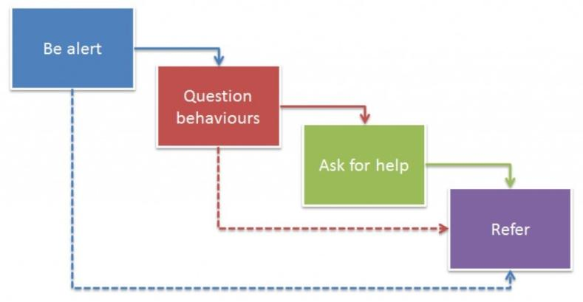

It is not always appropriate to go through all four stages sequentially and if a child, young person or vulnerable adult is in immediate risk or danger, a referral should be made immediately to social care and/or the police.

If a member of staff is concerned that a child or vulnerable adult is in immediate danger, or requires immediate medical treatment, they should call the police and/or emergency medical services on 999 straight away.

The Designated Safeguarding Lead or deputy, to whom the concerns are reported, has responsibility for deciding whether to refer the matter onto the relevant social services and/or the police and for making the referral.

The Designated Safeguarding Lead should:

- Refer any child /vulnerable adult protection concerns to Lambeth or Southwark Social Care or the Police, where there is:
  - clear evidence of abuse or concern for a child or vulnerable adult’s immediate safety,
  - concern that a child or vulnerable adult may be in need, including concerns about significant harm
  - a child has witnessed domestic violence, has suffered significant harm or is at risk of suffering significant harm through domestic violence. This includes situations where the child is yet to be born but the mother is at risk of domestic violence.
- Inform the Local Authority Designated Officer (LADO), Ofsted and, where appropriate, the DBS (Disclosure and Barring Service) without delay of any allegations of serious harm or abuse by any person working or looking after children at the premises

Referral should be made to the local authority in which the child or vulnerable adult is currently residing.

The Designated Safeguarding Lead must refer all actual or suspected cases of child abuse to:

- The Lambeth Safeguarding Children Board Integrated Referral Hub on 020 7926 3100 or 0207 926 5555 (24 hr)
- Southwark Safeguarding Children Board Multi Agency Safeguarding Hub on 020 7525 1921 or 020 7525 5000 (24 hr)

This includes concerns or allegations directly from children, parent/carer or another staff member. Child protection concerns must be referred regardless of whether the suspected or actual abuse has occurred on the childcare premises or at another location.

The Designated Safeguarding Officer must refer all actual or suspected cases of abuse of vulnerable adults to:

- Lambeth Adult Social Care Services on 020 7926 5555
- Southwark Adult Social Care on 020 7525 3324 (for adults with a physical or sensory disability or over 65), 020 7525 0088 (for adults with a mental illness) or 020 7525 2333 (for adults with a learning disability)

All referrals should be made within the same working day and all notifications made by telephone must be followed up by a written referral on referral form as soon as possible, but within 24 hours. The referral form should be emailed to the referral hub. If acknowledgement is not received from the hub the DSL should follow up to ensure it has been received.

- Allegations against members of staff and volunteers
Where it is alleged that a member of staff (including volunteers) has:
- behaved in a way that has harmed a child or vulnerable adult, or may have harmed a child or vulnerable adult;
- possibly committed a criminal offence against or related to a child or vulnerable adult; or
- behaved towards a child or children in a way that indicates he or she would pose a risk of harm to children or vulnerable adults
The matter must be brought immediately to the attention of the Designated Safeguarding Lead. If the Designated Safeguarding Lead is the subject of the allegation, then this should be reported to the Group Director Iain Tuckett and/or the Coin Street Safeguarding Trustee Jo-Anna van der Bosch.
The Local Authority Designated Officer (LADO) and Ofsted will then be informed immediately for further advice and guidance. A full investigation will be carried out by the appropriate professionals (LADO, Ofsted) to determine how this will be handled. Coin Street reserves the right to suspend any member of staff during an investigation.
- Key contacts

Safeguarding Team – report all concerns, disclosures and available for advice
Designated Safeguarding Lead | David Hopkins | Coin Street Neighbourhood Centre – 2nd Floor | 020 7021 1654 / 07884 655 120 | d.hopkins@coinstreet.org
Deputy Designated Safeguarding Leads | Hommie Beharry | Coin Street Neighbourhood Centre – 2nd Floor | 020 7021 1623 / 07894 422 008 | h.beharry@coinstreet.org
 | Rehema Essop | Coin Street Neighbourhood Centre – 1st Floor | 020 7021 1676 | r.essop@coinstreet.org
 | Jane Christofi | Coin Street Neighbourhood Centre – 1st Floor | 020 7021 1676/ 07884 667 857 | j.christofi@coinstreet.org
 | Rehema Essop | Coin Street Neighbourhood Centre – 1st Floor | 020 7021 1676 / 07824 140 880 | r.essop@coinstreet.org
 | Natalie Bell | Coin Street Neighbourhood Centre – 2nd Floor | 020 7021 1622 / 07375 040 441 | n.bell@coinstreet.org
 | Melanie Davies | Coin Street Neighbourhood Centre – 2nd Floor | 020 7021 1643 / 07827 242 413 | m.davies@coinstreet.org
Safeguarding Trustees – report if the allegation is against the Designated Safeguarding Lead
Safeguarding Trustee | Jo-Anna van der Bosch | Not based in the building |  | joantvdb@aol.com
Group Director | Iain Tuckett | Coin Street Neighbourhood Centre – 2nd Floor | 020 7021 1608 | i.tuckett@coinstreet.org
Making a safeguarding referral or seeking advice (this would usually be done through Safeguarding Team but referrals can be made directly when necessary)
Re Lambeth children | Lambeth Safeguarding Children Board Integrated Referral Hub |  | 020 7926 3100 / 0207 926 5555 (24hr)
Re Southwark children | Southwark Safeguarding Children Multi Agency Hub (MASH) |  | 020 7525 1921 / 020 7525 5000 (24hr)
Re Lambeth vulnerable adults | Lambeth Adult Social Care |  | 020 7926 5555
Re Southwark vulnerable adults with physical or sensory disability or over 65 | Southwark Adult Social Care |  | 020 7525 3324
Re Southwark vulnerable adults with a mental illness | Southwark Adult Social Care |  | 020 7525 0088
Re Southwark vulnerable adults with a learning disability | Southwark Adult Social Care |  | 020 7525 2333
Local Authority Designated Officer (LADO) – reporting allegations against staff, volunteers, or trustees (usually through the Safeguarding Team)
Lambeth LADO | Andrew Zachariades |  | 020 7926 4679 / 07720 828 700 | LADO@lambeth.gov.uk
If a child or vulnerable adult is at immediate risk or needs medical attention |  |  | Call 999

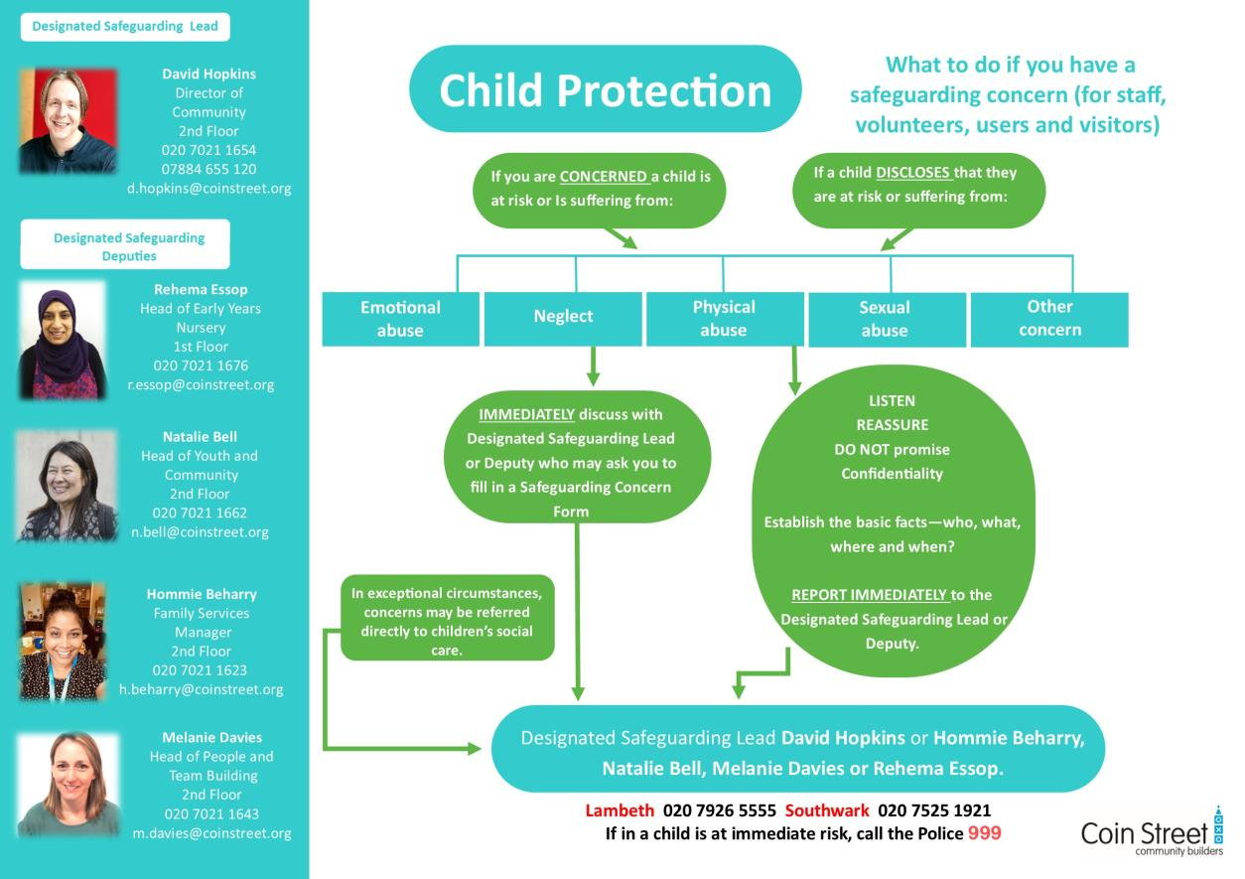
Appendix 1 Coin Street safeguarding concerns form
Safeguarding Children/Young People/Vulnerable Adults Concern Form

Your name:
Your role:
Date:
Place that disclosure / behaviour / incident seen:
Concerning: (names if known)
This is a: | Child |  |  | Youth |  | Adult
Date of Birth (if known):

Attending what group / session:
Describe what you saw, and heard & any actions taken (Factual account)
Any appendices attached?
Your signature:

Record passed to:
Date & Time:

Action Taken:
Date | Person taking action | Action | Signature
Skin Map - Clearly mark on the skin map below where the child has been marked
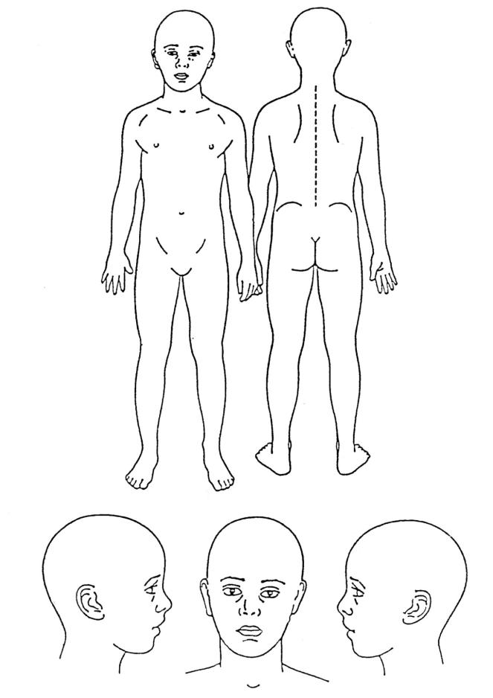

Would you like feedback about this concern? | Yes |  | No

Please ensure you pass this to the Designated Safeguarding Lead or Deputy Lead - hard copy or scan and send e-copy.

Thank you for keeping children, young people and vulnerable adults safe.

